Name : Bhavesh Punjabi
Class : D15A
Roll : 40

Experiment 6 :Implementation of K-Means Clustering Using Python
Aim
To implement the K-Means clustering algorithm using Python on the Seeds dataset and analyze the clustering results using the Elbow Method, Silhouette Score, Inertia, Davies-Bouldin Index, and data visualization.
Theory
Clustering:
Clustering is an unsupervised machine learning technique used to group similar data points based on their characteristics. It identifies patterns and structures in a dataset without requiring predefined labels. Common clustering algorithms include K-Means, DBSCAN, and Hierarchical Clustering. Clustering is widely used in customer segmentation, anomaly detection, image analysis, and data mining.
K-Means Clustering:
K-Means is an unsupervised learning algorithm that divides a dataset into a predefined number of clusters (K). It assigns each data point to the nearest cluster centroid and repeatedly updates the centroids until the clusters stabilize. The main objective is to minimize the variation within each cluster.
Seeds Dataset:
The Seeds dataset contains 210 instances of wheat seeds belonging to three varieties: Kama, Rosa, and Canadian. Each instance has seven numerical attributes: area, perimeter, compactness, length of kernel, width of kernel, asymmetry coefficient, and length of kernel groove. These attributes help identify similarities among seeds through clustering.
Evaluation Metrics:
- Elbow Method: Helps determine the optimal number of clusters by plotting the inertia for different values of K. The elbow point indicates a suitable number of clusters.
- Silhouette Score: Measures how well each data point fits within its assigned cluster compared with other clusters. Its value ranges from -1 to 1, with higher values generally indicating better-separated clusters.
- Inertia: Measures the sum of squared distances between data points and their assigned cluster centroids. Lower inertia indicates more compact clusters, although it generally decreases as K increases.
- Davies-Bouldin Index: Measures the similarity between clusters using their internal distances and the distances between their centroids. A lower value generally indicates better-separated and more compact clusters.
Tools Required
- Python 3.x
- Jupyter Notebook or Google Colab
- Libraries: Pandas, NumPy, Matplotlib, Seaborn, and Scikit-learn
- Seeds dataset in CSV format
Code
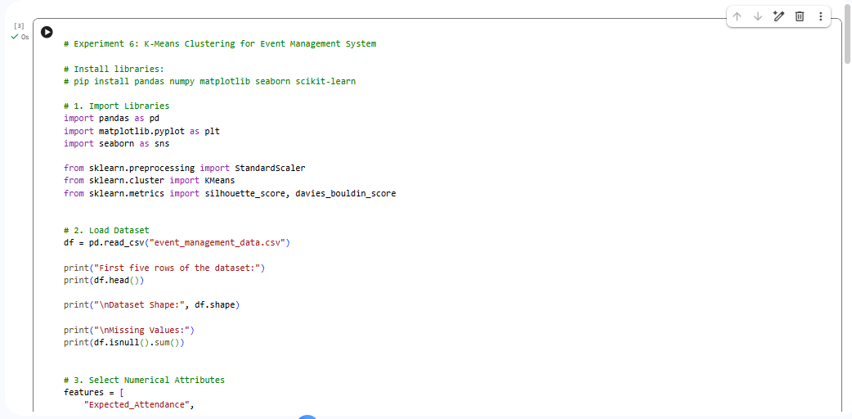
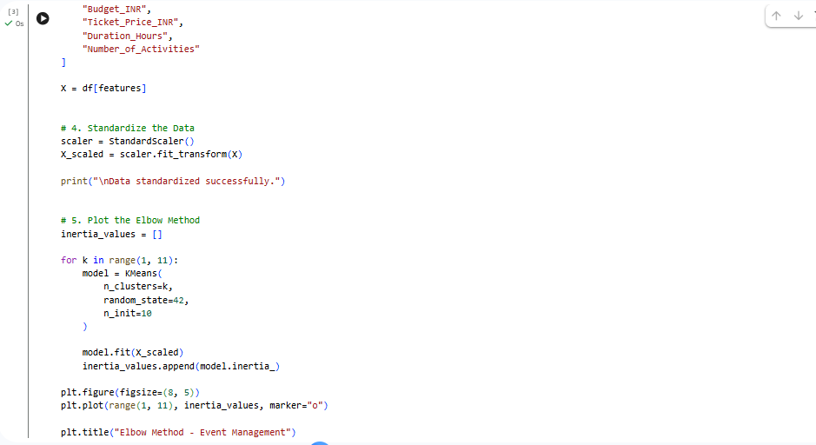
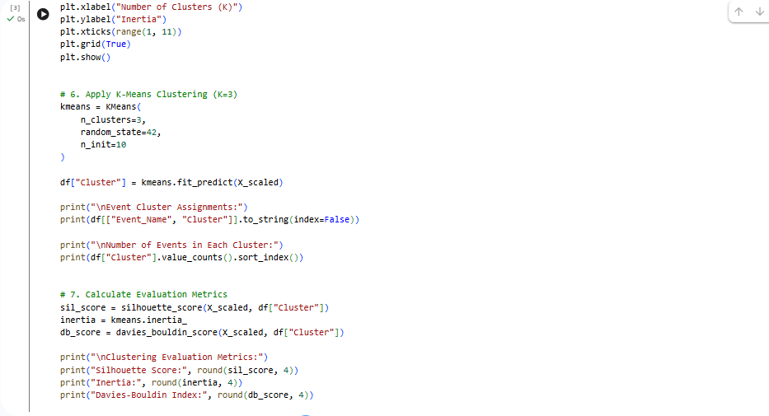
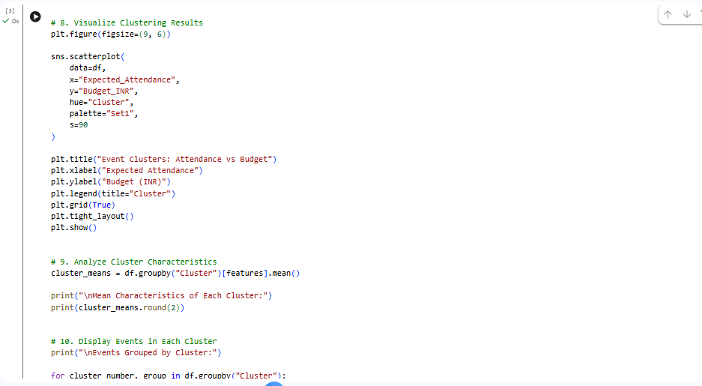
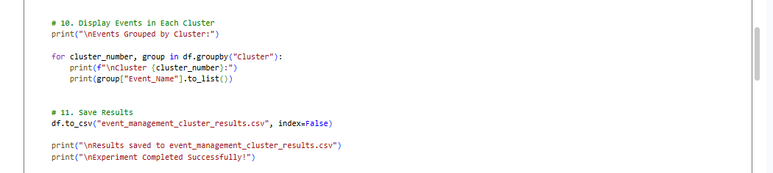

Output
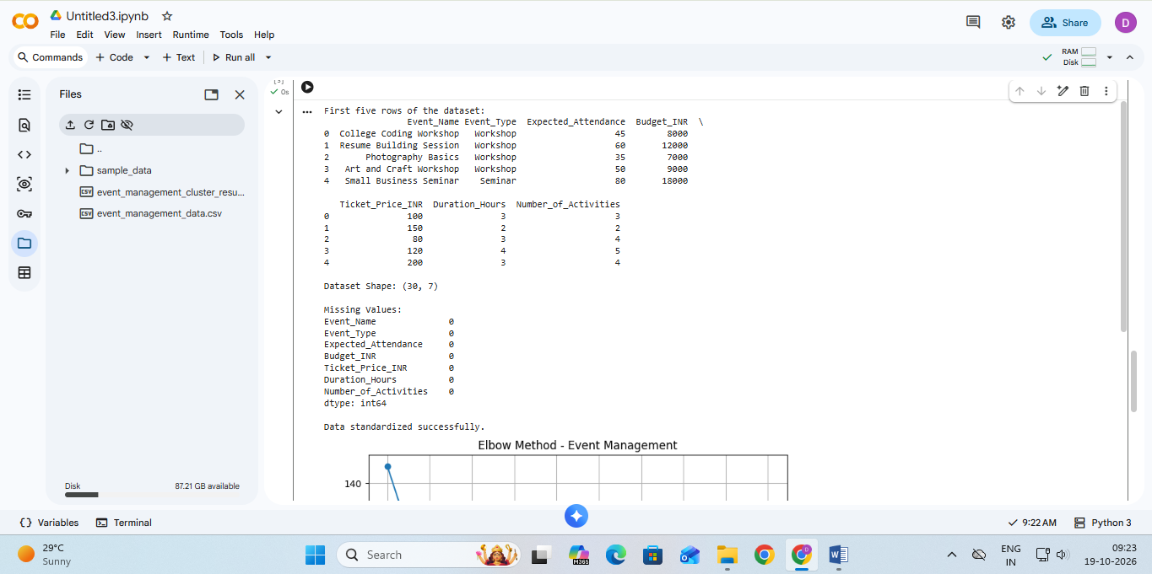
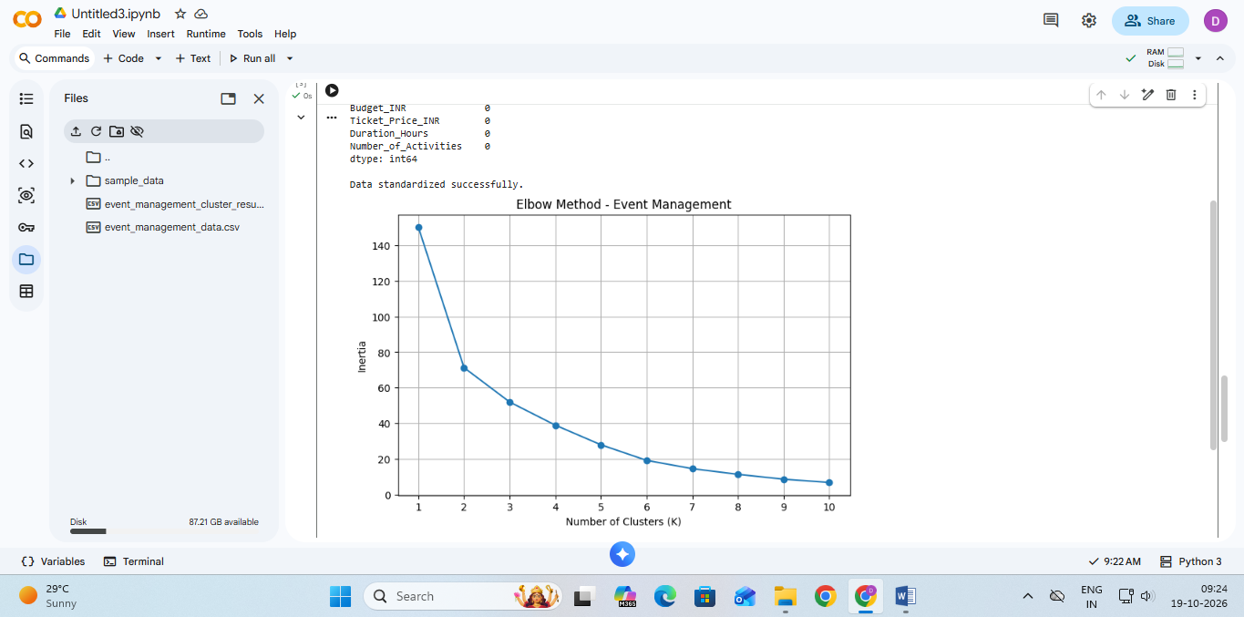

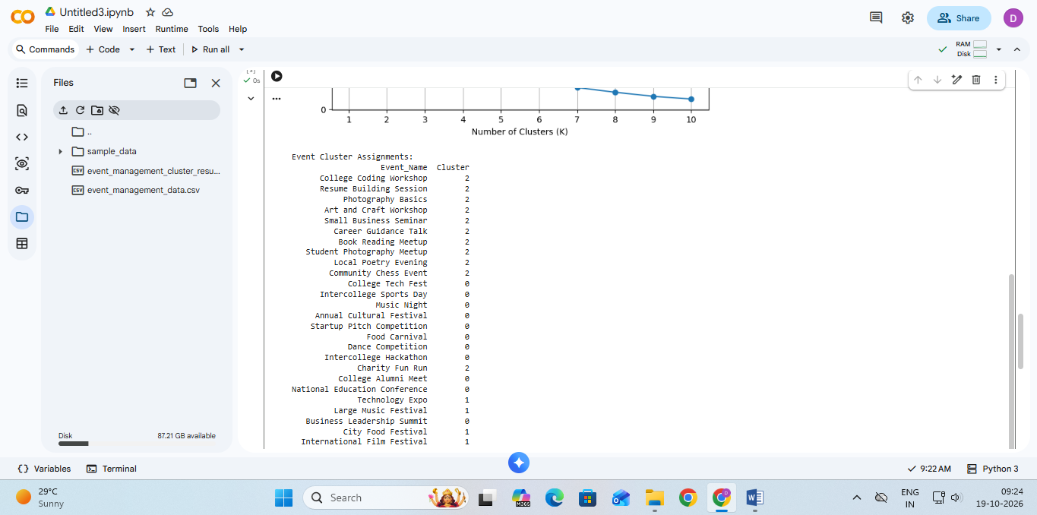

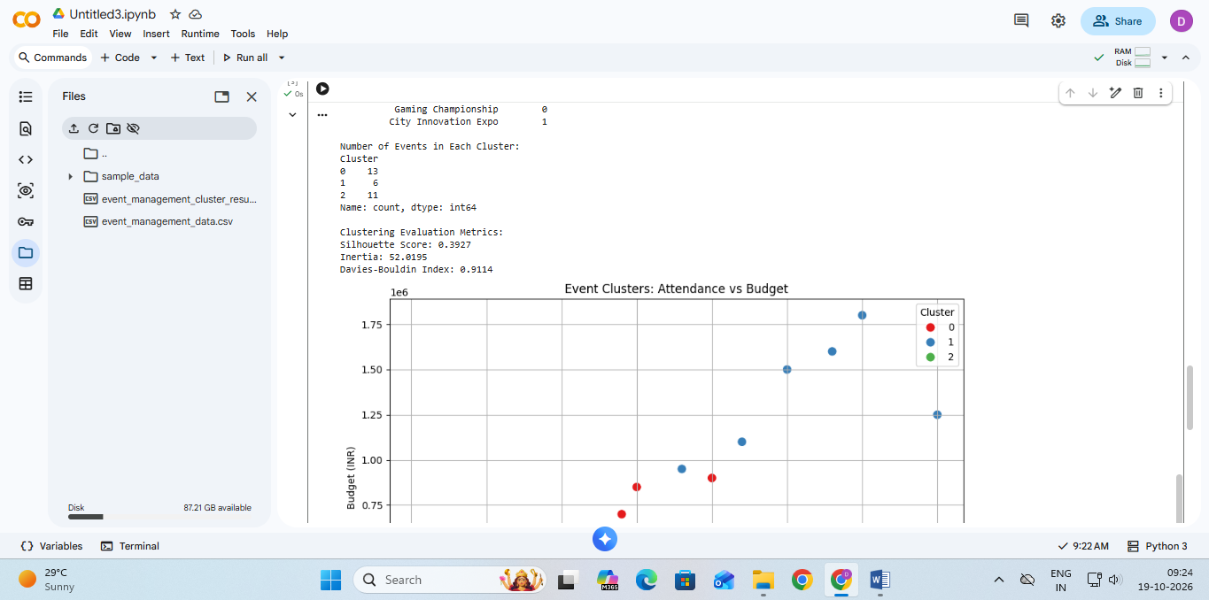

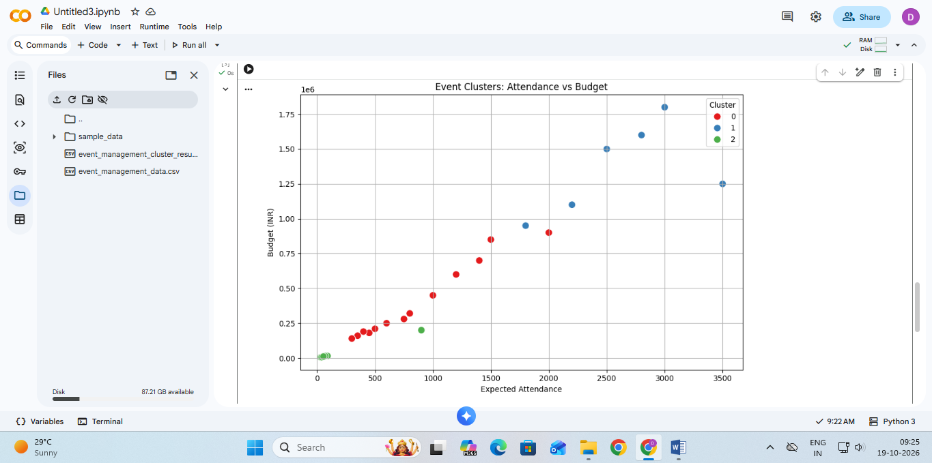

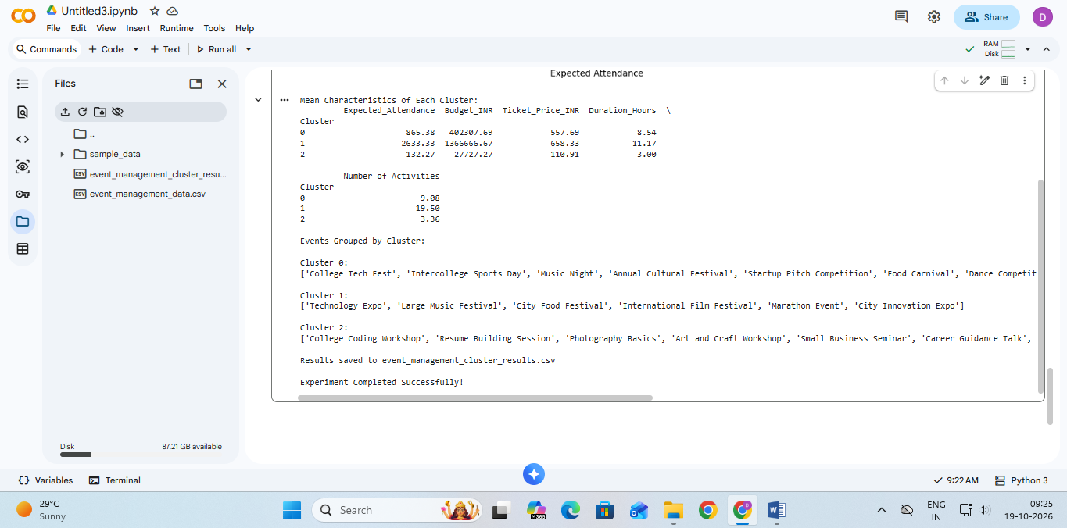

Inference

Result

Conclusion

============================================================
GitHub Repository Link:
https://github.com/Sentry2311/DMBI_EXPERIMENTS/tree/main/Experiment_06_KMeans_Clustering_Python
(Contains complete documentation, dataset, and program code for Experiment 6: K-Means Clustering Using Python)

